EXP NO: 4
7 SEGMENT DISPLAY USING AT89C51 USING PROTEUS

Output:
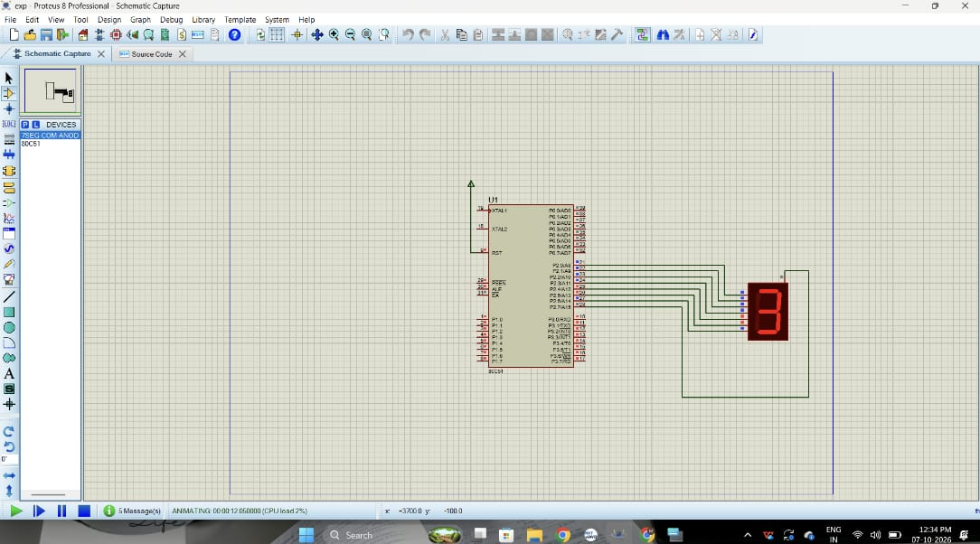

Code:
